**How does Self Book Work?**

Patients will receive a text message with their unique booking link. Once they've clicked on the link they will be prompted to enter their date of birth.

[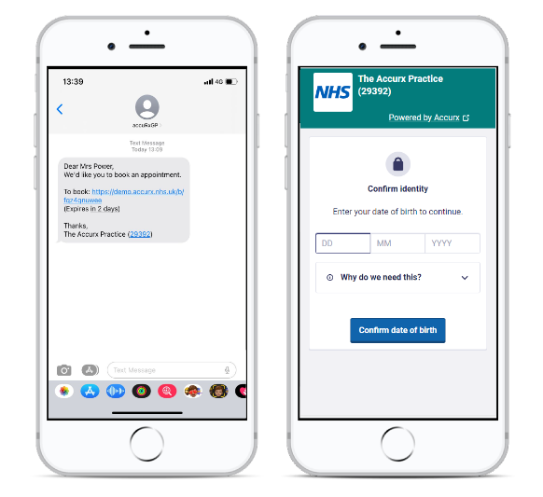](https://downloads.intercomcdn.com/i/o/695733232/79918dabb7cc5fca11e49072/image.png?expires=1719418500&signature=09a0e8ce9f0a478b4b46dddd1119178268394824651379e9bca0d01dc2c108a8)

**For telephone appointments**, the patients will be able to choose a convenient time window for the telephone call AM or PM

**For face-to-face appointments**, the patients will be able to choose a convenient time slot for their in-person appointment 👨🏽‍⚕️

[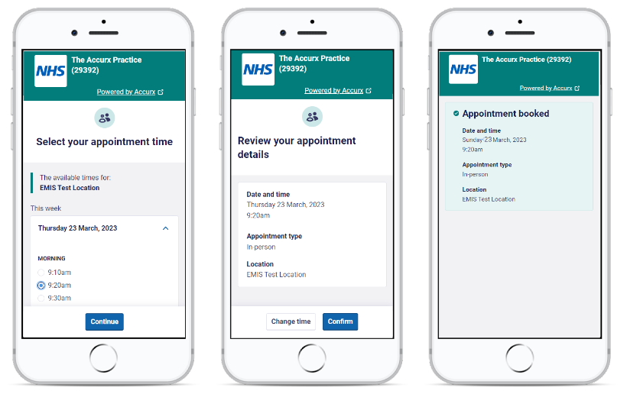](https://downloads.intercomcdn.com/i/o/695722338/b2c51280f754b3c31d3bf08d/image.png?expires=1719418500&signature=d7ca83ad50383ec077169740e9b6099699817e6c74df6dfe96973d36df11cd98)

The patient will then receive a confirmation SMS with the appointment details